**Professional Programming Practice – Assignment 4**

**HOANG, Van Cuong**

**11613599**

**BUG 6 – Notice about age permission should shown**

**Description:** The player is only allowed to play the game if he/she is over 18 years old. If the player is under 18, a notice should be shown and the game cannot be started.

1. **Replication.**

Rule number ten of the game:



In the Main class, after starting the game there is no line of code that mentions the age permission to play the game:

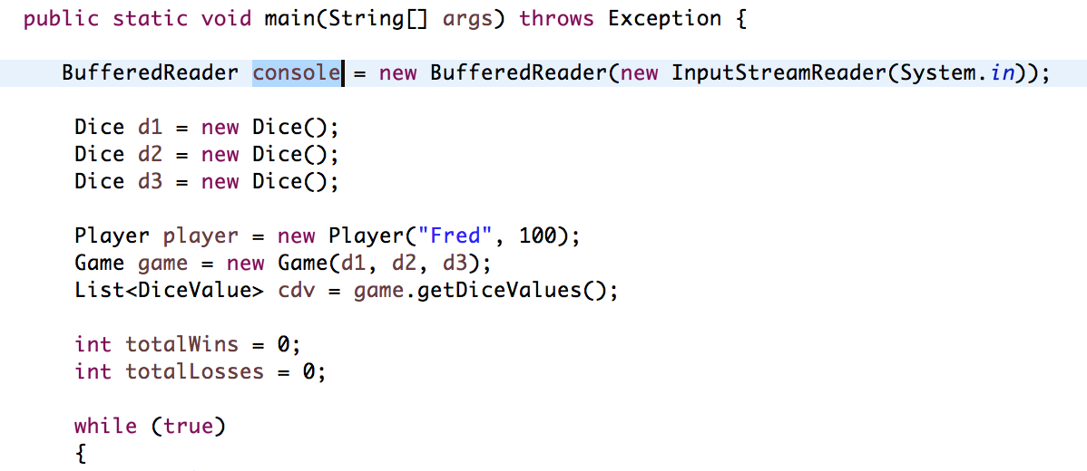

**2. Simplification**

At start, the program should ask the user to input his age. After checking the age, the program responses with approciate actions.

**3. Tracing**

Please read the comments to see which actions should be taken at which points:

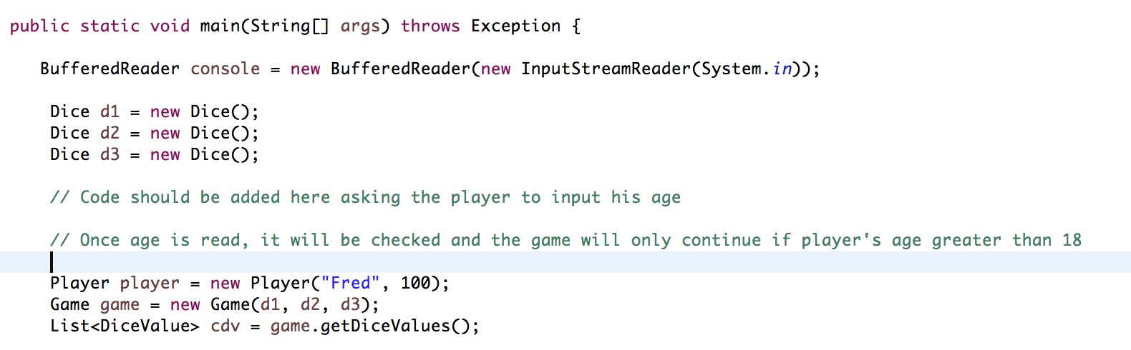



**4. Resolution**

Code should be added as bellow:

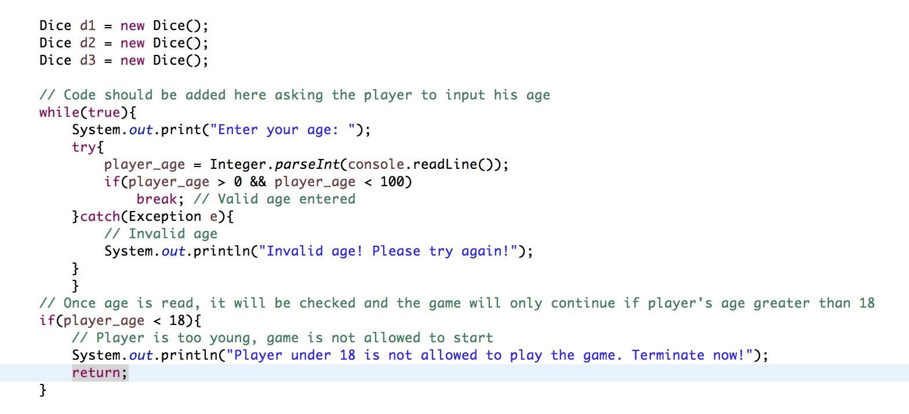

And when the game starts, it asks player to enter his age:

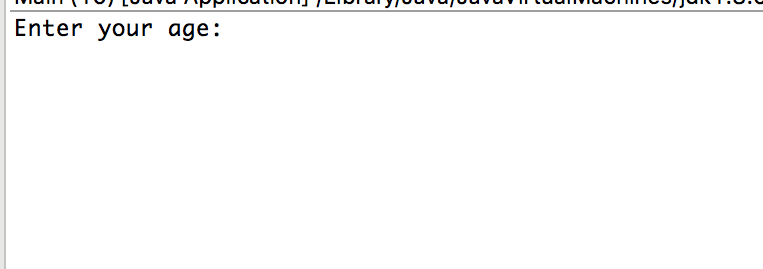

If the player enters a string, it keeps asking again and again:

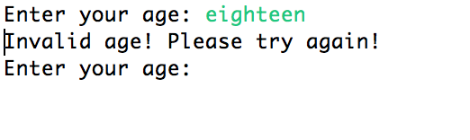

If the player is 18 or older, game allows him to play:

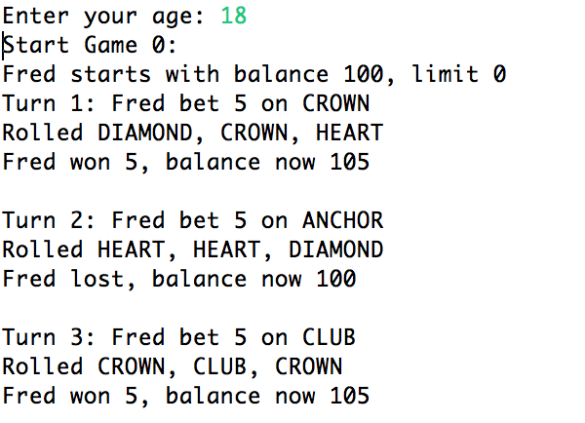

What if the player is younger?

